Lab 4: Build a RAG skill flow

In this lab, you will create a RAG Skill Flow, integrating search with Watson Discovery and Gen AI platform watsonx.ai. Using this, you will be able to build a Q&A assistant for procurement guidelines.

[screenshot procurement scenario with highlight]

Build a skill flow

In order to build a skill flow, you need to do the following:

1. Add skills in personal skills
2. Create the skill flow
3. Add skills to the skill flow
4. Connect the input and output of skills
5. Enhance and Publish the skill flow

Follow the steps below for detailed instructions.

1.Add skills in personal skills

1.1 Add“Watson Discovery” search skill as personal skill

1.1.1 In the Chat Menu click on “Add Skills from the catalog”

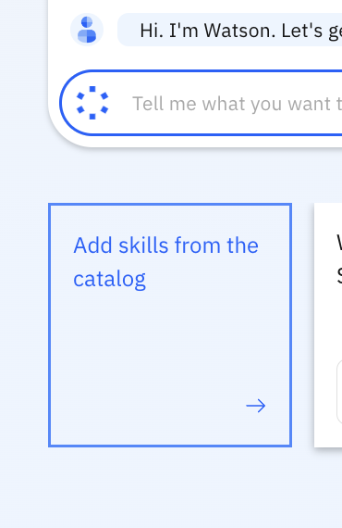

1.1.2 Select “Watson Discovery Search” and click on “Add Skill”

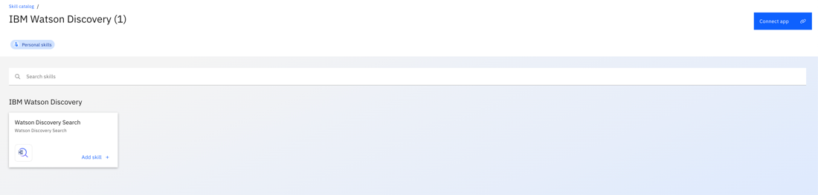

1.1.3 To connect to the Skill, click on “Connect app” and provide the following API details provided in the Skill Connection Details.docx file.

1.2 Add “Content Generation (Async)” watsonx.ai skill as personal skill [skip this if you have completed lab 3]

2. Create skill flow

2.1 Select “Create Skill Flow”

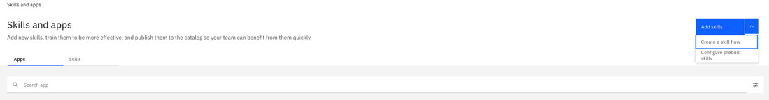

2.2 Name the Skill Flow as “[Your Name] RAG”

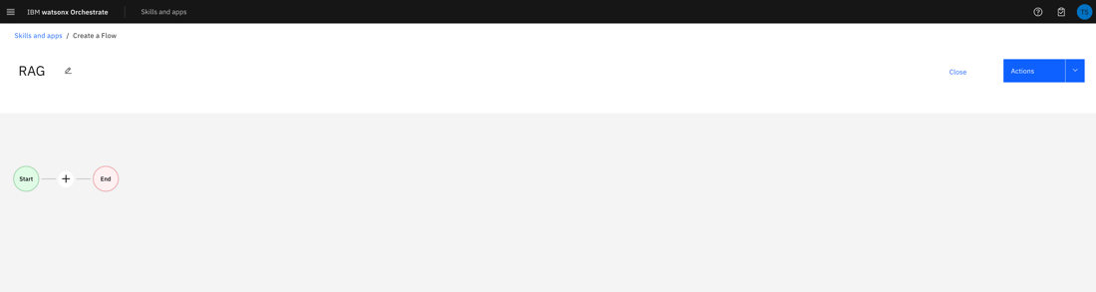

3. Add skills to the skill flow

3.1 Add input form as first skill.

3.1.1 Select “Custom Forms” from All apps menu

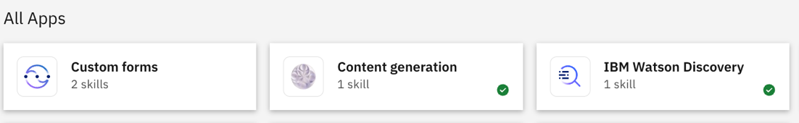

3.1.2 Select “Input Form” from Custom Skills and click on “Add Skill”

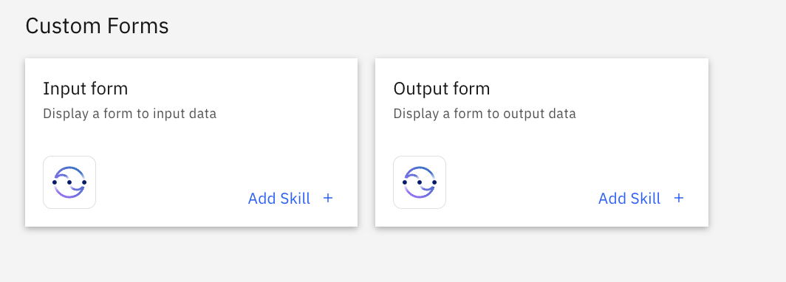

3.2 Add "IBM Watson Discovery” as the second skill

3.2.1 Select IBM Watson Discovery from All apps menu



3.2.1 Select “Watson Discovery Search” and click on “Add Skill”

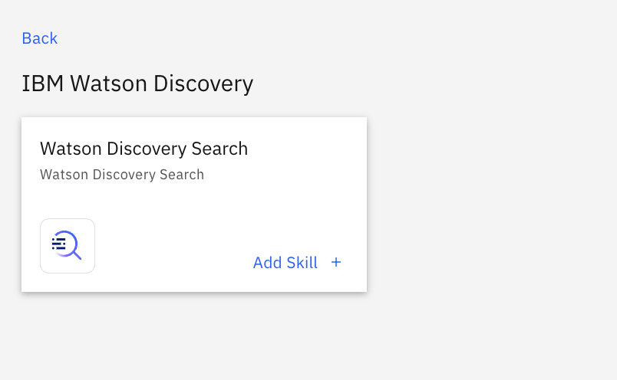

3.3 Add Content Generation as third skill

3.3.1 Select Content Generation from All apps menu



3.3.2 Select “Content Generation” and click on “Add Skill”

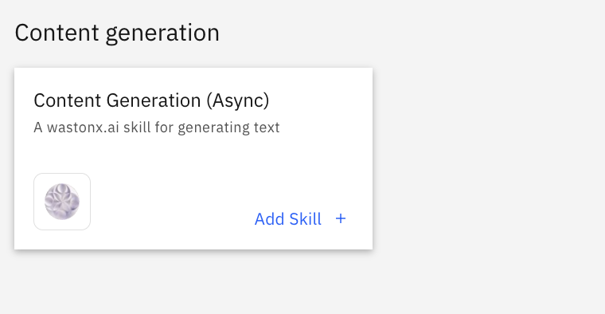

4. Connect the input and output of skills

4.1 Configure the Input field

4.1.1 In the Input Form, select “Add Input field”

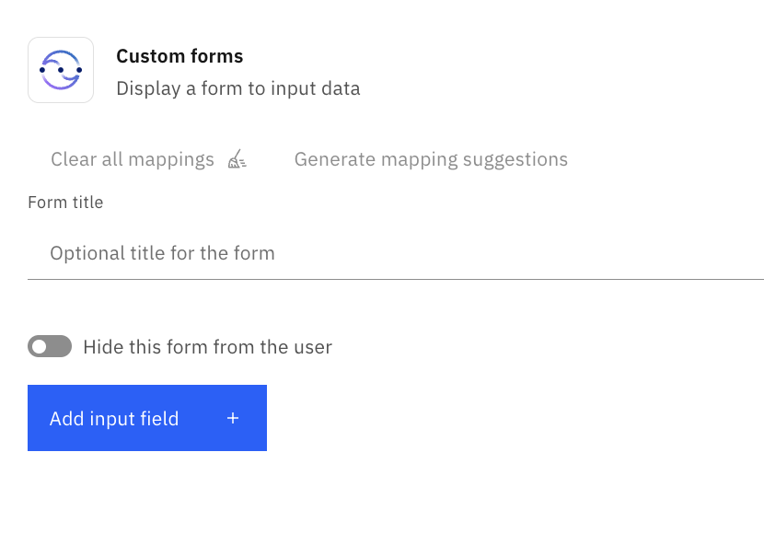

4.1.2 Select “Single-line Text” as Input type and Display label as “User Question”. Select Apply

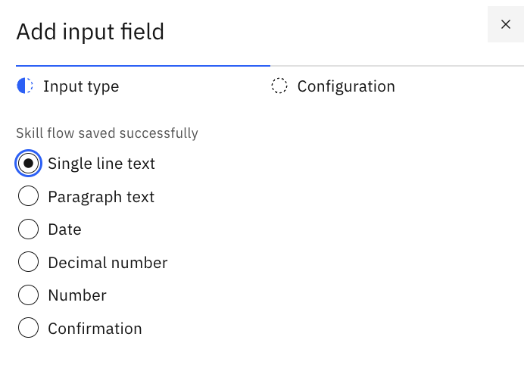

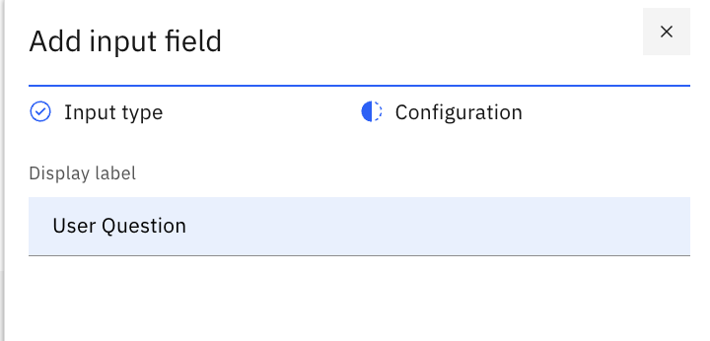

4.2 Configure “Watson Discovery Search”

4.2.1 In the Input section of Watson Discovery Search, select natural language query as User Question from Input form

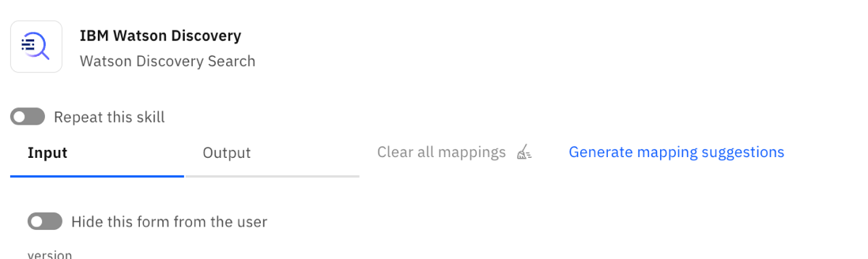

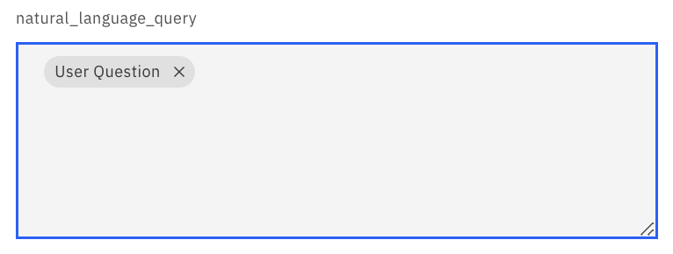

4.3 Configure “Content Generation”

4.3.1 In the Input section of Content Generation, select input and write a simple prompt.

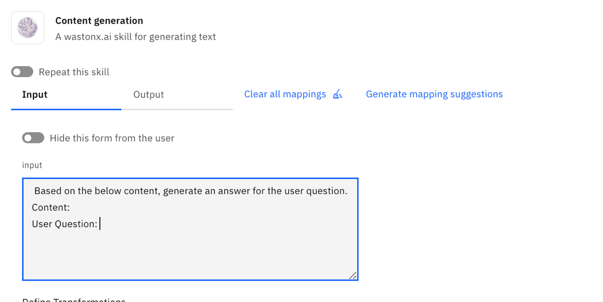

4.3.2 Attach the discovery response in the Content. Select the document_passages -> passage_text option from Watson Discovery Search

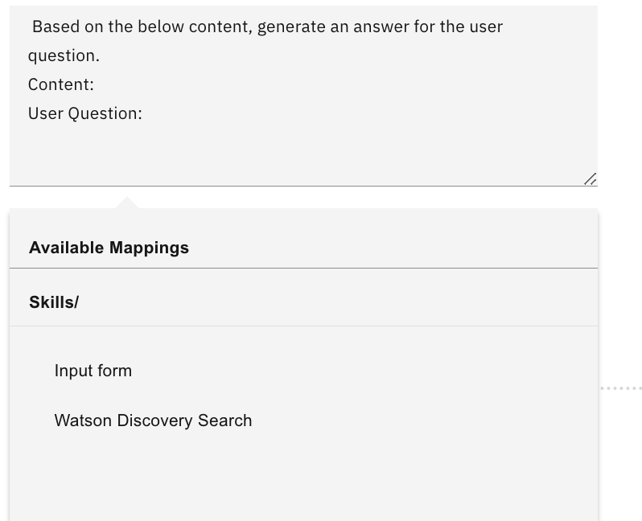

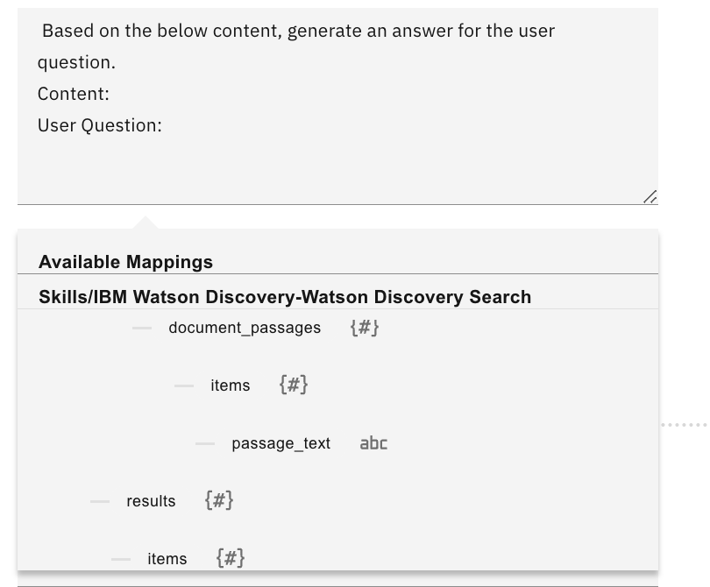

4.3.3 Attach the User Question from Input Form.

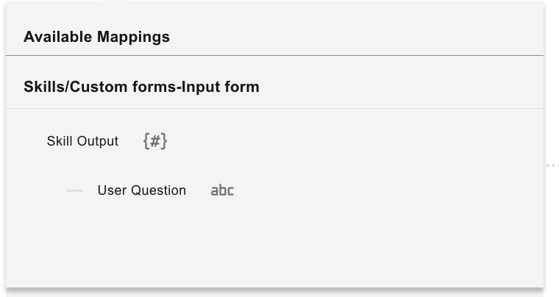

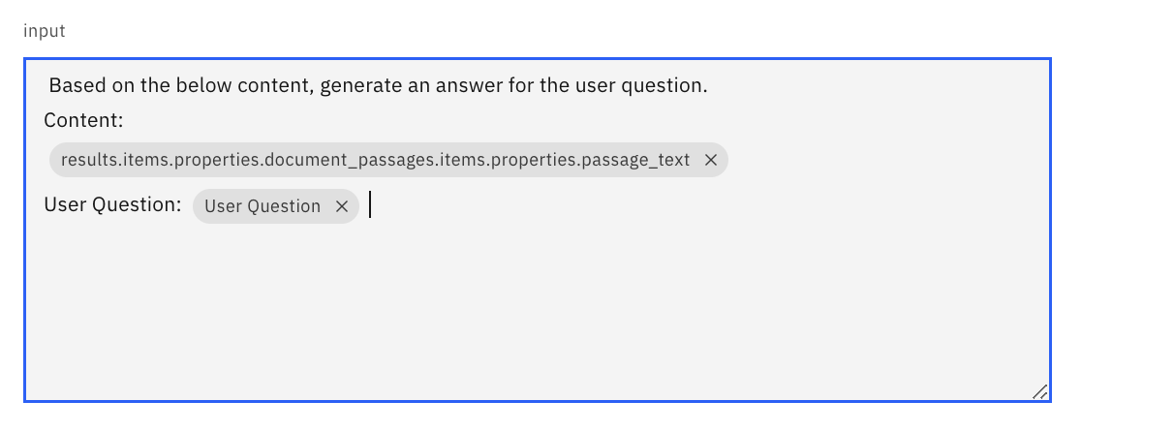

4.3.4 Add watsonx.ai project id provided in the Skill Connection Details.docx file as default value in “project_id”.

4.4 Save and Publish the skill flow

4.4.1 Select “Actions” and save the skill flow as draft.

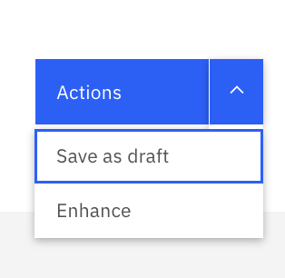

4.4.2 Select Enhance from Actions menu to Publish the skill flow and click on Publish.

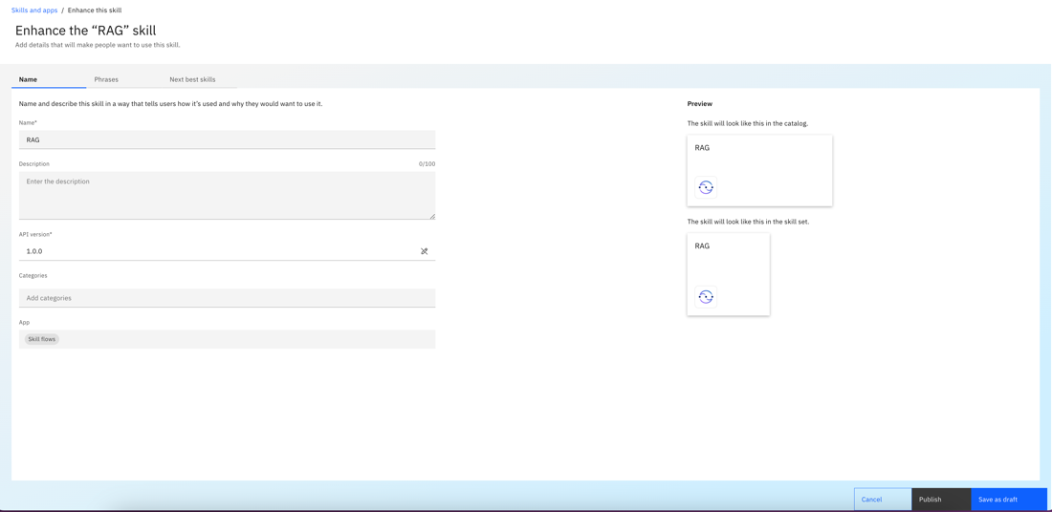

4.5 Add Skill flow to Chat Menu from “Add Skill flow to Catalog”

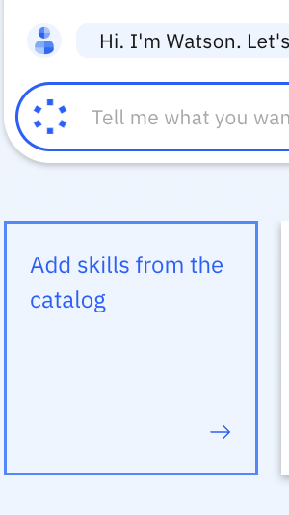

4.5.1 Search for RAG and select Skill Flows. Select RAG and click on “Add Skill”

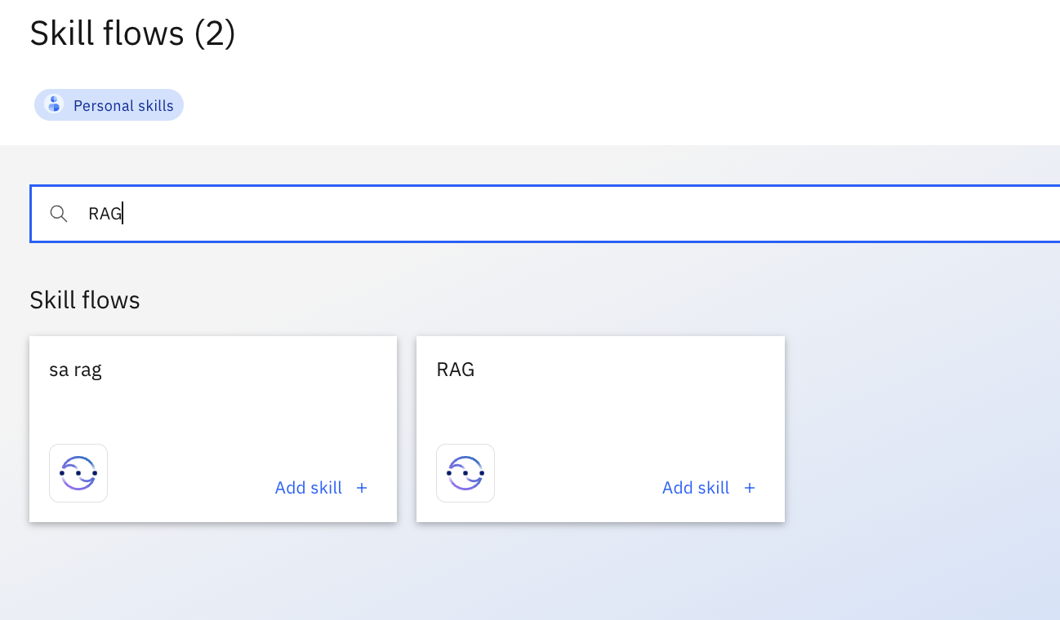

5. Use a Skill flow

5.1 Select RAG skill flow for using the skill flow. Add a user question “What are Procurement Requisition (PR) rules ?” and select Apply.

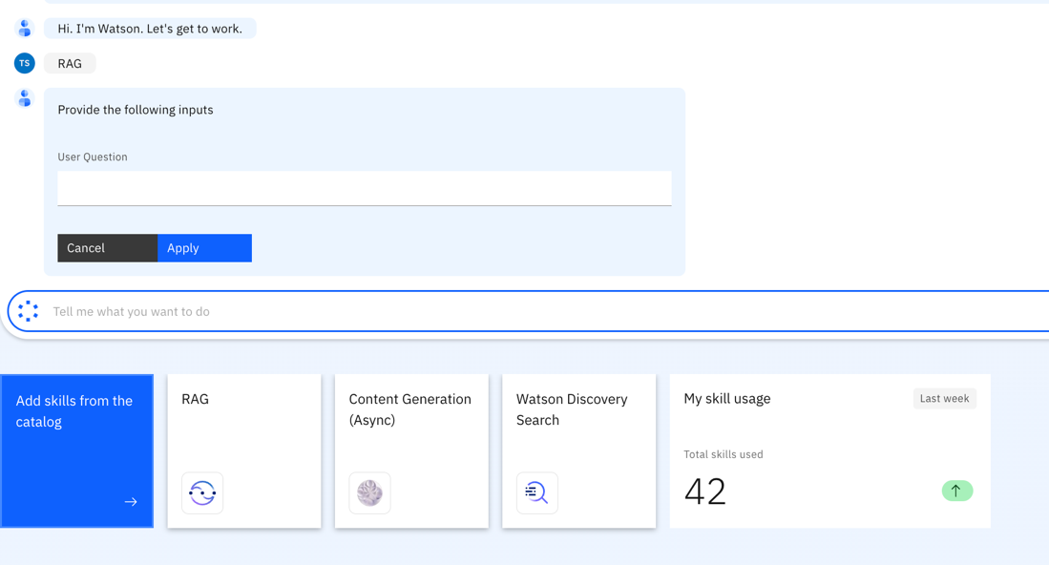

5.2 Watson Discovery skill is triggered and some of the parameters are pre filled in the form. Click on Apply.

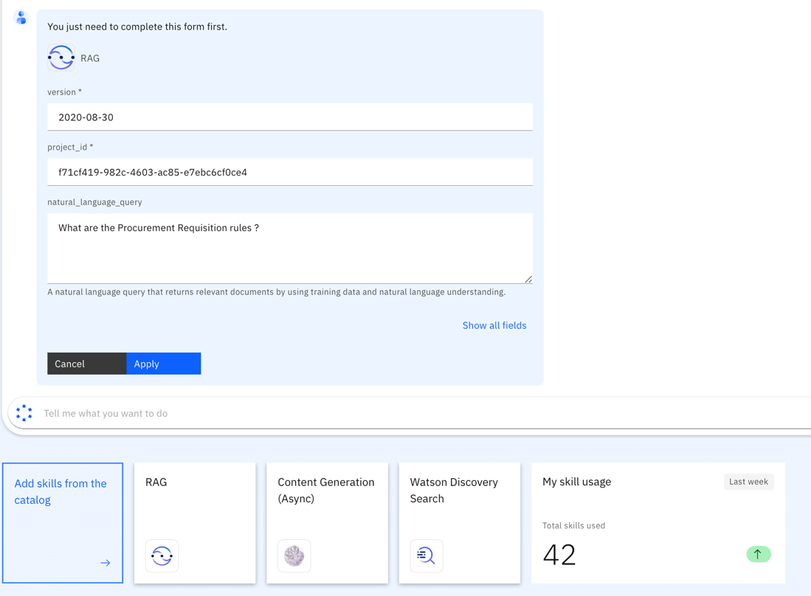

5.3 Watson Discovery returns relevant passages for the User Question. Select the option and click on Apply.

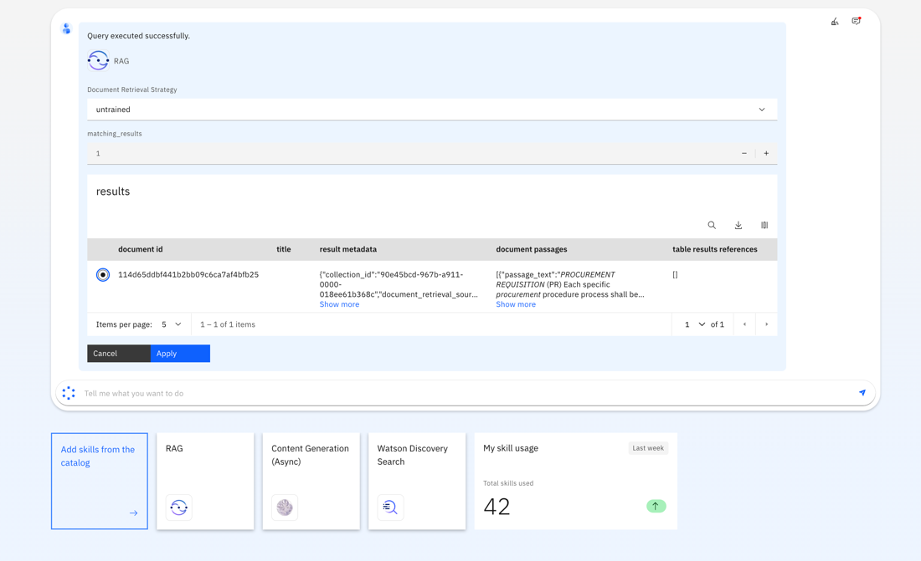

5.4 Content Generation flow is triggered and based on the relevant chunk, the prompt gets populated. Select Apply.

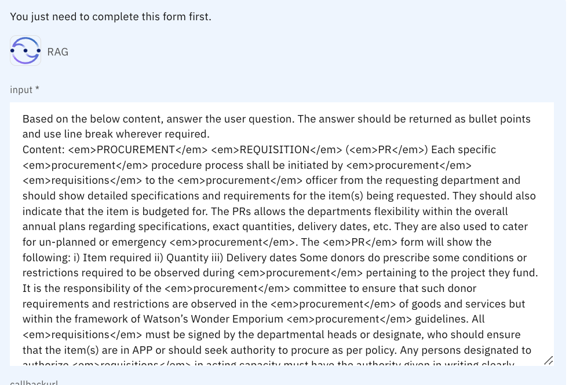

5.4 An answer will be generated based on the provided paramters and the user question.

